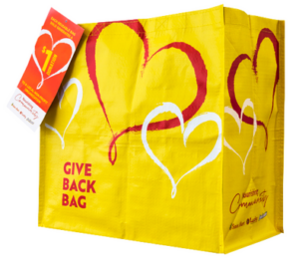
GIVE BACK BAG PROGRAM

Launch Day Email

SUBJECT: Launch Day for Lucky Give Back Bag Program!

Hello,

Today is launch day for the Lucky Give Back Bag Program! Starting today and for the entire month of [month of selection], when you purchase a $2.50 Give Back Bag at the Lucky located at [location], $1 is donated to [name of organization].

Our goal is to sell [goal of bags bought, e.g., 200] bags, equivalent to $[insert donation equivalent, e.g., $200] raised. We are confident that with the help of our dedicated supporters we can reach this goal.

We strongly encourage you to share this news with family and friends as well!

The reusable Give Back Bags are located on displays around the store and at the checkout. For more information about the program, please visit tsmc.2givelocal.com.

Thank you for your support,

[Signature]

