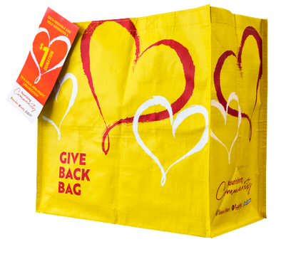
GIVE BACK BAG PROGRAM

Announcement Email

SUBJECT LINE: We’ve been selected by the Lucky Give Back Bag Program!
PREVIEW TEXT: For all of [Month], we will receive $1 for every Give Back Bag purchased at Lucky!

Dear [Staff/Board/Volunteers/Supporters],

We are so excited to share that [organization] has been selected to benefit from Lucky’s Give Back Bag Program, which makes it easy for shoppers to contribute to their local communities.

For the month of [month], whenever a $2.50 Give Back Bag is purchased at the Lucky located at [location], $1 will be donated to [organization]. This is a great way to broaden awareness and help our cause.

The Lucky Give Back Bag Program, which launched in February 2022, is a reusable bag program that facilitates community support with the goal of making a difference in the communities where shoppers live and work.

Let’s get started! Share the news with friends and family. Call, send emails, and post on social media. The more people who purchase the reusable Give Back Bag in [month], the greater the donation we will receive!
To learn more about this program, please visit tsmc.2givelocal.com.
Best,

[Signature]

