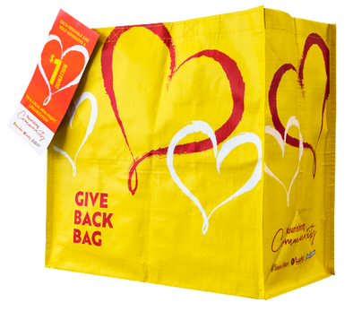
GIVE BACK BAG PROGRAM

Sample Email

SUBJECT LINE: We’ve been selected by the Lucky Give Back Bag Program!
PREVIEW TEXT: For all of [Month] every Give Back Bag purchased at Lucky earns us $1!

Dear [Staff/Board/Volunteers],

We are so excited to share that [organization] has been selected to benefit from Lucky’s Give Back Bag, which makes it easy for customers to contribute to their local communities.

For the month of [month], whenever a $2.50 Give Back Bag is purchased at the Lucky located at [location], $1 will be donated to [organization]. This is a great way to broaden awareness and help our cause.

Let’s get started! Share the news with friends and family. Call, send emails and post on social media. The more people who purchase the reusable Give Back Bag in [month], the more we can raise!
To learn more about this program, please visit tsmc.2givelocal.com.
Best,
[Signature]

tsmc.givelocal.com

