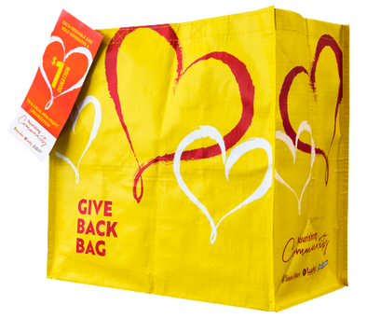
GIVE BACK BAG PROGRAM

Thank Your Supporters Email & Social Post

SUBJECT: Thank you for your support!

Hello,

Through the FoodMaxx Give Back Bag Program, we received $[money raised] in donations from bag sales in the month of [benefiting month]!

We extend a HUGE thank you for your participation and support during our benefiting month of the FoodMaxx Give Back Bag Program. Whether you bought a bag or helped spread the word, we couldn’t have done this without you. The money generated will help us to [share what you’ll do with the donations]. Thank you again for making this a fun and successful experience for [name of the organization].

Share With Your Followers
Thank you! We raised $[donation amount] through the FoodMaxx Give Back Bag Program!
Your everyday choices make a difference in our community!

tsmc.2givelocal.com

